Learning Conjunction Dynamics: A Self-Supervised Approach to Satellite Collision Risk Assessment

Ahmad Alharbi ¹, Abdulelah Mojelad ², Hamzah Alharbi ³, Khalid Alsadoon ⁴, Mohamedhakim Hassan⁵

¹ Department of Aerospace Engineering, Faculty of Engineering, King Abdulaziz University, Jeddah 23835, ahmadharbi157@hotmail.com
² Department of Computer Science, Faculty of Computing and Information Technology, King Abdulaziz University, Jeddah 23826, abdulellah.mazen@gmail.com
³ Department of Aerospace Engineering, Faculty of Engineering, King Abdulaziz University; Jeddah 23353, hamzahawad789@gmail.com
⁴ Department of Aerospace Engineering, Faculty of Engineering, King Abdulaziz University; Jeddah 23235, eng.khalid.alsadoon@gmail.com
⁵ Department of Aerospace Engineering, Faculty of Engineering, King Abdulaziz University; Jeddah 23241, mohamedhakim1901@gmail.com

Abstract
The rapid increase in tracked space objects has introduced significant operational challenges for satellite operators, particularly in distinguishing credible collision threats from the large volume of low-quality conjunction alerts generated by space surveillance networks. This study introduces a self-supervised deep learning method for assessing the credibility of conjunction alerts, addressing the core limitation that actual satellite collisions are too infrequent to provide labeled training data for supervised classification. A bidirectional gated recurrent unit architecture with Monte Carlo Dropout was trained on 185,511 conjunction data messages collected from January to June 2024. The model learned to predict the evolution of collision probability, miss distance, and covariance parameters from historical conjunction data message sequences without relying on human-defined threat labels. On a test set of 6,411 unique conjunction events, the model achieved a mean absolute error of 0.403 for collision probability prediction and a log-scaled collision probability R-squared of 0.649, demonstrating effective learning across an eight-order-of-magnitude probability range from 10⁻¹⁰ to 10⁻². A four-quadrant risk classification framework that integrates model-derived threat scores with Monte Carlo Dropout uncertainty estimates produces operationally realistic distributions. This framework identified 4 percent of events as requiring immediate attention and safely deprioritized 56.5 percent as routine conjunctions, resulting in a 96 percent reduction in urgent alerts. The approach supports real-time processing, with 25-minute training on standard CPU hardware and millisecond-scale inference, making it suitable for operational deployment in space traffic management workflows. These findings demonstrate that self-supervised learning with uncertainty quantification can effectively address conjunction screening challenges without requiring collision outcome labels or fixed probability thresholds.

Keywords: Self-Supervised Learning; Satellite Conjunction Screening; Monte Carlo Dropout; Uncertainty Quantification; Space Traffic Management.

Introduction
The sustainability of operations in Low Earth Orbit (LEO) faces significant threats due to increasing orbital congestion, primarily caused by the rapid deployment of mega-constellations and the heightened risk of catastrophic debris generation [1]. This congestion imposes a large volume of Conjunction Data Messages (CDMs) on satellite operators, which requires timely and precise avoidance maneuvers. This operational context reveals a critical limitation in traditional risk assessment approaches: reliance on fixed thresholds or deterministic models often results in excessive false-positive alerts, leading to unnecessary propellant expenditure and compromising both mission sustainability and profitability [2].

1.1 The Operational Challenge and Technical Gap
The overwhelming volume of CDMs has rendered manual processing by human operators unsustainable, necessitating advanced automation. This challenge is intensified by the vast number of debris fragments in orbit and the persistent risk of the Kessler Syndrome, in which a single collision can trigger a cascade of additional debris [2]. A central operational challenge is the lack of a robust mechanism to assess prediction reliability before executing costly maneuvers.
Traditional methods, which depend on fixed probabilistic thresholds or deterministic models, remain highly vulnerable to data instability and uncertainties in covariance measurements. This vulnerability compels operators to choose between accepting the risk of a catastrophic false negative, such as a missed collision, or incurring the guaranteed cost of a resource-depleting false positive, such as an unnecessary maneuver. The consequent depletion of the satellite's propellant reserves directly undermines mission sustainability.
To address this challenge, this study applies Artificial Intelligence and Machine Learning (AI/ML) techniques to develop a scalable, confidence-weighted operational solution.

1.2 Rationale Solution and Technical Innovations
To achieve the required reliability, this research introduces the Self-Supervised CDM Trajectory Learning System, a novel framework designed to convert raw CDM time-series data into confidence-weighted operational directives. The methodology is based on two core principles: addressing the lack of ground truth labels and quantifying prediction uncertainty.
- Self-Supervised Trajectory Learning: To address the challenge posed by the extreme rarity of actual collision outcomes, which makes standard supervised learning impractical, a self-supervised learning paradigm is employed. The model is trained to predict the parameters of the subsequent CDM (CDM_{n}) in a sequence, using its historical data (CDM₁ to C_{n-1}). This prediction task leverages a robust Bidirectional Gated Recurrent Unit (BiGRU) architecture, a variant of Recurrent Neural Networks (RNNs), to capture the generalized trajectory dynamics of conjunction evolution. This approach enables the model to learn valid dynamics directly from data patterns.
- Built-in Uncertainty Quantification: Monte Carlo Dropout is applied during inference to generate a continuous Model Confidence Level. This measure is essential for distinguishing between genuine threats and data instability.
The primary objective of this research is to validate the effectiveness of confidence-weighted risk assessment in optimizing operational resource efficiency, and the main conclusion is that the uncertainty-aware framework delivers superior operational efficiency. The model effectively filters the majority of screened events into the SAFELY IGNORE category, providing operators with the assurance required to conserve propellant while maintaining high-confidence identification of the limited cases necessitating immediate intervention. By converting probabilistic risk into clear, confidence-supported operational directives, this solution directly contributes to the long-term sustainability of the LEO environment.

Methodology
Our method integrates robust data handling, trajectory-based sequence learning, bidirectional recurrent neural network architecture, and Monte Carlo uncertainty quantification into a unified operational framework. Each methodological component is explained in detail, from reading raw CDMs files through the final four-quadrant risk classification scheme. This will make the workflow easy to repeat and understand the proposed solution.

2.1 Overview and Approach
A self-supervised deep learning architecture is presented for satellite conjunction risk analysis. The model learns conjunction dynamics directly from historical CDM sequences, quantifying both predictive uncertainty and assessment confidence without relying on the threshold-based rules or probabilistic components common to traditional approaches. The framework comprises five core stages:

Robust parsing and enrichment of raw CDM data in Key-Value Notation (KVN) format.

Feature engineering and self-supervised sequence construction.

Bidirectional GRU training with Monte Carlo (MC) Dropout.

Behavior-derived threat and confidence scoring.

Four-quadrant risk classification.

2.2 Data Acquisition and Preprocessing
The dataset contains 185,511 CDMs, covering global conjunction screenings from 1 January to 30 June 2024, sourced from Aldoria and the SSA DebrisSolver competition partnership. Due to severe timestamp corruption in the supplied CSV (approximately 60% unreadable), a custom Python parser was developed to process the original KVN files directly. The parser extracts 11 features per CDM: collision probability Pc, $\log_{10}(Pc)$, Time to Closest Approach (TCA) in hours, Combined Radial-Transverse-Normal (RTN) positional uncertainty (cr_r + ct_t + cn_n), relative speed magnitude, and three relative position and velocity components in the primary object’s RTN coordinate frame. The custom parsing approach achieved 99.95% timestamp recovery, retaining 185,415 valid CDMs out of the original 185,511. Features were standardized using a StandardScaler fitted on the training set. Prior to normalization, miss distance was clipped to the range [$1, {10}^{5}$] m and $Pc \left[{10}^{-10},{10}^{-2}\right].$

2.3 Self-Supervised Sequence Learning
Conjunction events were grouped by unique concatenated NORAD IDs and sorted chronologically. Events containing ≥2 CDMs were formed into input–target pairs. Given a historical sequence up to timestep $n-1$, the task is defined as [3]:
$$Input: \left\{{CDM}_{1},…….,{CDM}_{n-1}\right\}→Target: {CDM}_{n} for all n∈\left\{2,…N\right\}$$
Using past CDMs, the model predicts the feature vector at timestep n via the function:
$$f: R^{(n-1)×11}→R^{11}$$
The maximum sequence length was fixed at 20 timesteps, which covers 86.4% of events directly (90% of events contain 13 or fewer CDMs). Events exceeding 20 CDMs generated multiple overlapping windows of 20, while shorter events were zero-padded to the fixed size and masked during training. An event-level random 80/10/10 split yielded 77,989 training sequences (51,287 events), 9,598 validation sequences (6,411 events), and 9,637 test sequences (6,411 events).

2.4 Neural Network Architecture and Training
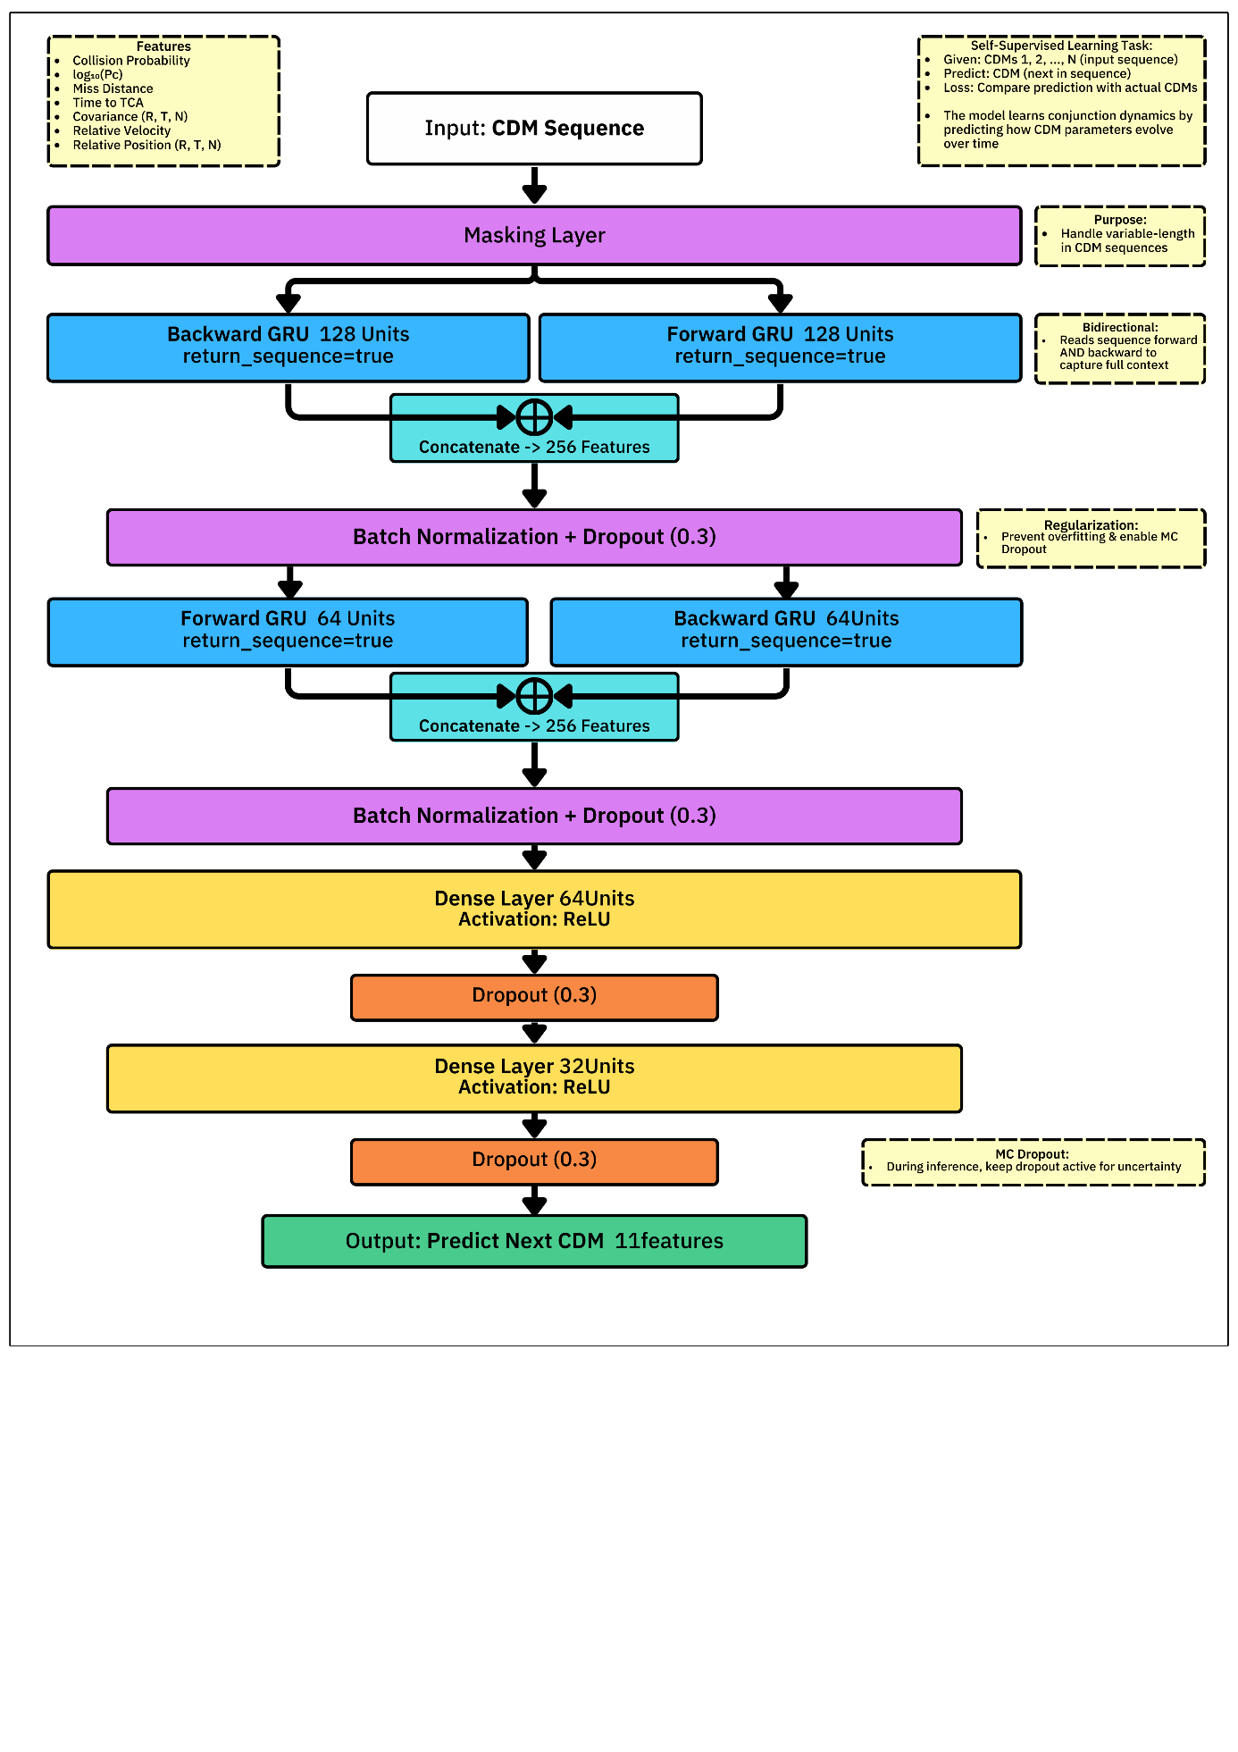
The proposed solution utilizes a stacked bidirectional GRU network [4] capable of processing variable-length sequences in both forward and backward temporal directions, as illustrated in Figure 1.

Figure 1: The model architecture features two stacked Bidirectional GRU layers followed by dense layers, incorporating Batch Normalization and Monte Carlo Dropout for uncertainty quantification.

The architecture begins with a masking layer to handle padded inputs, followed by a first Bidirectional GRU layer with 128 units in each direction. The resulting outputs are then concatenated, normalized via Batch Normalization, and regularized with a Dropout rate of 0.3. This is followed by a second Bidirectional GRU layer with 64 units per direction, which also undergoes concatenation, Batch Normalization, and Dropout (0.3). The features obtained passed through two fully connected dense layers (64 and 32 units, respectively) using ReLU activation, each followed by Dropout (0.3), before projecting to the final output 11-feature vector.
The model with 244,171 parameters was trained to minimize the Weighted Mean Squared Error (wMSE), assigning higher weights (importance) to critical features: log₁₀ Pc (2.0), miss distance (1.5), and uncertainty features (1.2). Training used the Adam optimizer with learning rate (lr=0.001), batch size of 64, and a maximum of 150 epochs, with early stopping (patience=20) and learning rate reduction on plateau. Model performance on the held-out test set (10%) is quantified by using three complementary regression metrics [5,6]. These metrics are defined by the following formulas in Equations (1-5):
2.4.1 Weighted Mean Squared Error (wMSE)
(1)
$$L=\frac{1}{B}\sum_{i=1}^{B}{\sum_{j=1}^{11}{w_{j}}.{\left(y_{ij}-{\hat{y}}_{ij}\right)}^{2}}$$
(2)
$$wMSE=\frac{1}{N}\sum_{i=1}^{N}{\sum_{j=1}^{11}{w_{j}}.{\left(y_{ij}-{\hat{y}}_{ij}\right)}^{2}}$$
2.4.2 Mean Absolute Error (MAE)
Calculated per-feature and overall:
(3)
$${\text{MAE}}_{j}=\frac{1}{N}\sum_{i=1}^{N}{∣y_{ij}-{\hat{y}}_{ij}∣}{ \text{MAE}}_{\text{overall}}=\frac{1}{N×11}\sum_{i=1}^{N}{\sum_{j=1}^{11}{∣y_{ij}-{\hat{y}}_{ij}∣}}$$
(4)
$${\text{MAE}}_{Pc}=\frac{1}{N}\sum_{i=1}^{N}{∣P_{c_{i}}^{pred}-P_{c_{i}}^{true}∣}$$
2.4.3 Coefficient of Determination (R2)
(5)
$$R_{j}^{2}=1-\frac{\sum_{i=1}^{N}{(y_{ij}-{\hat{y}}_{ij})^{2}}}{\sum_{i=n}^{N}{(y_{ij}-{\overset{ˉ}{y}}_{j})^{2}}}$$
(6)
$${\overset{ˉ}{R}}^{2}=\frac{1}{11}\sum_{j=1}^{11}{R_{j}^{2}}$$

2.4.4 Uncertainty Quantification
Uncertainty is quantified via Monte Carlo (MC) Dropout at inference (50 forward passes(T=50), p=0.3) [7]. The final prediction is the mean across passes, and the epistemic(model) uncertainty is the standard deviation. Equation (7-8) calculates mean and standard deviation with notations adjusted for consistency [8,9,10]:
(7)
$$\hat{y}=\frac{1}{T}\sum_{i=1}^{50}{f(x;w,d_{i})}$$
(8)
$$σ_{pred}=\sqrt{\frac{1}{T-1}\sum_{i=1}^{50}{ {\left(f(x;w,d_{i})-\hat{y}\right)}^{2}}}$$
Where $(w)$ represents the deterministic weights from the final training epoch, and (d_{i}) is the Bernoulli mask applied at the ($i_{th}$) inference pass.

2.5 Threat and Confidence Scoring
To enable interpretable decision-making, model output is expressed into specific Threat and Confidence metrics. The Threat score (0–100) combines: predicted collision probability, Pc trends, inverse miss distance, and time urgency. It is given by
(9)
$$Threat=50*(1+tanh⁡(α.\log_{10}\left(P_{c}^{pred}\right)+β))$$
Where $α$ and $β$are calibrated to map the typical Pc range $[{10}^{-10}to {10}^{-2}]$ smoothly to 0-100 scale.
Confidence level (0–1) combines three signals: inverse MC Dropout variance, number of observed CDMs (data uncertainty), and prediction consistency across the 50 MC iterations. Each signal is turned into 0-1 score and combined with weights that sum to 1 to get final confidence. At the event level, aggregation method includes: maximum threat score across all predictions (worst-case), recency-weighted average confidence, and the final observed Pc from the last CDM.
2.5.1 Operational Classification
Events are categorized using a binary threshold of Threat = 50 and Confidence = 0.5, resulting in a four-quadrant risk classification:
- ACT NOW: Threat ≥ 50 and Confidence ≥ 0.5
- WATCH CLOSELY: Threat ≥ 50 and Confidence < 0.5
- SAFELY IGNORE: Threat < 50 and Confidence ≥ 0.5
- NOT PRIORITY: Threat < 50 and Confidence < 0.5

Results & Discussion
This section presents the performance evaluation and operational analysis of the bidirectional GRU model, which was trained on 185,511 conjunction data messages collected during the first half of 2024. The results are organized into six categories: model training performance and convergence behavior, validation of the self-supervised learning approach, operational risk classification outcomes, uncertainty quantification using Monte Carlo Dropout, architectural design rationale, and identified limitations with proposed directions for future research. The test set consisted of 9,637 samples from 6,411 unique conjunction events, enabling a robust assessment of the model's generalization to previously unseen satellite encounters.

3.1 Model Training Performance
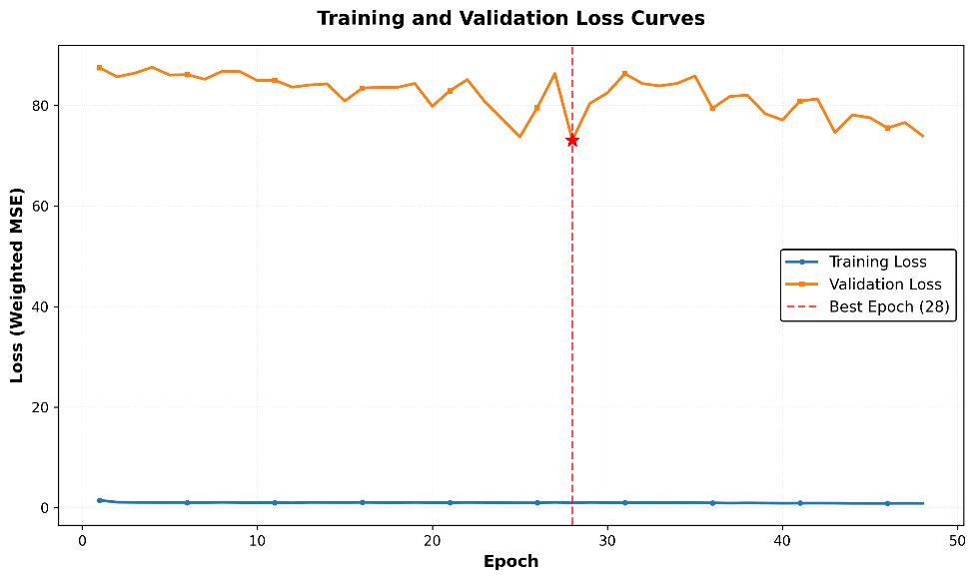
The bidirectional GRU model underwent training for 48 epochs with early stopping, selecting epoch 28 as optimal based on validation loss. Training was completed in 24.8 minutes using standard CPU hardware. Figures 2-5 illustrate training convergence, with smooth learning curves and no evidence of instability or divergence. The weighted mean squared error (MSE) loss Figure 2 decreased from approximately 88 to 73 on the validation set, while the overall mean absolute error (MAE) Figure 3 improved consistently, indicating minimal overfitting. Notably, the collision probability prediction error Figure 4 decreased from 0.54 to 0.43 on the training set and from 0.44 to 0.41 on the validation set, demonstrating effective learning of the most operationally significant feature.
Figure 2: Training and Validation Loss Curves

On the held-out test set, which included 9,637 samples from 6,411 unique conjunction events, the model achieved an overall MAE of 0.464 across all normalized features. The collision probability MAE of 0.403 demonstrates strong predictive accuracy for risk assessment. The log₁₀(Pc) R² score of 0.649 indicates that the model accounts for 65% of the variance in collision probability predictions. The consistency between validation 0.41 and test 0.404 collision probability MAE further confirms appropriate generalization and absence of overfitting.

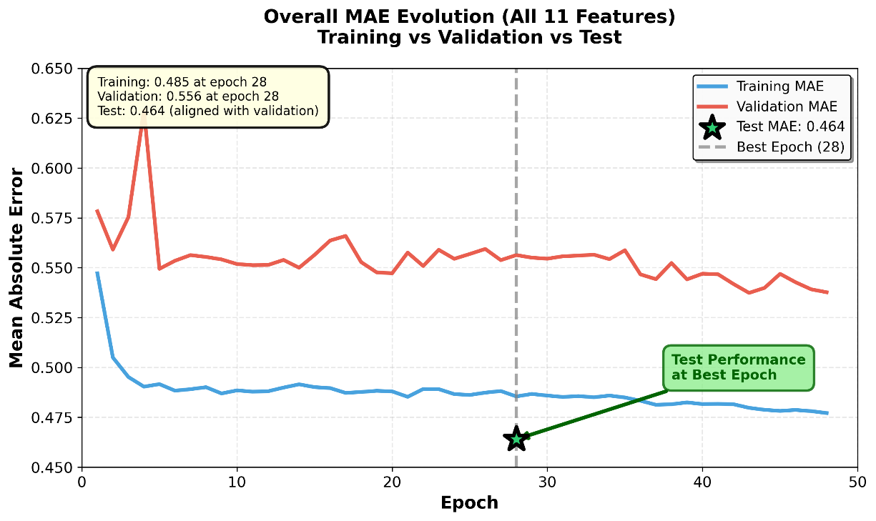
Figure 3: Training and Validation MAE Curves

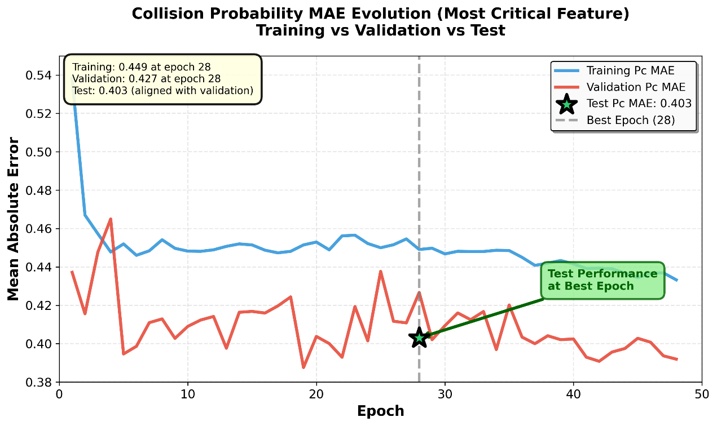
Figure 4: Collision Probability Prediction Error

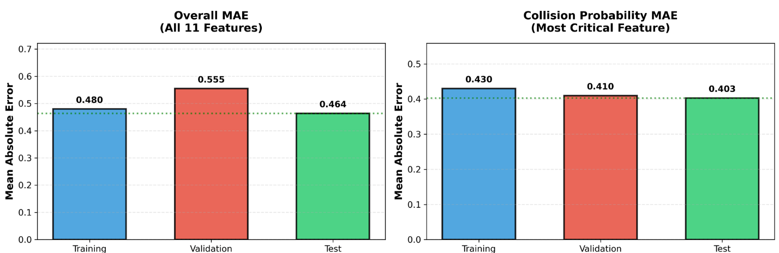
Figure 5: Metrics Comparison

3.2 Self-Supervised Learning Validation
A primary challenge in this study was the absence of ground-truth collision outcomes for supervised training, given the rarity of actual satellite collisions. Analyzing the relationship between model-derived threat scores and actual collision probabilities shows whether the self-supervised approach identified meaningful risk patterns or arbitrary mappings. Figure 6 shows a strong positive correlation between threat scores and final Pc values, with a linear regression slope of 2.86, confirming that the model independently discovered risk relationships from CDM sequence patterns without explicit labeling.
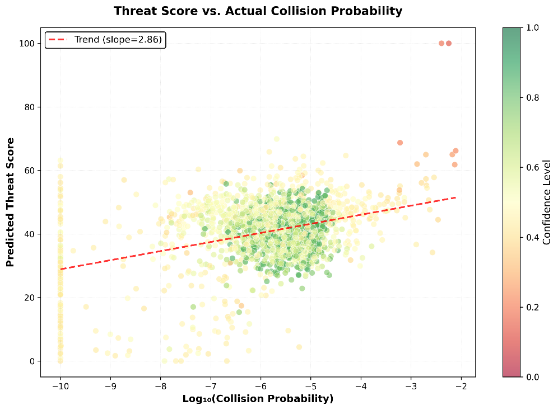
Figure 6: Threat Score vs Actual Collision Probability

The self-supervised framework was particularly effective at managing the extensive dynamic range of collision probabilities, spanning eight orders of magnitude (from approximately 10⁻¹⁰ to 10⁻²) in the dataset. By learning to predict subsequent CDM parameters from historical sequences, the model implicitly captured the evolution of credible threats over time. Events with stable, low Pc trajectories received low threat scores, whereas events with increasing Pc or high final values were assigned higher scores. This emergent behavior supports the core hypothesis that trajectory patterns, rather than instantaneous threshold crossings, offer superior risk discrimination.
The model's threat assessment mechanism was developed solely through minimizing prediction error on CDM sequences, without reliance on human-defined criteria for identifying "high-risk" trajectories. The strong correlation between threat scores and actual Pc Figure 6, together with the log₁₀(Pc) R² of 0.649, demonstrates that self-supervised learning effectively extracted the underlying physics and operational logic present in the CDM data. This methodology differs fundamentally from threshold-based screening systems, which apply fixed rules irrespective of trajectory context, and it avoids the labeling bias inherent in supervised classification where human operators define threat categories.

3.3 Operational Risk Classification
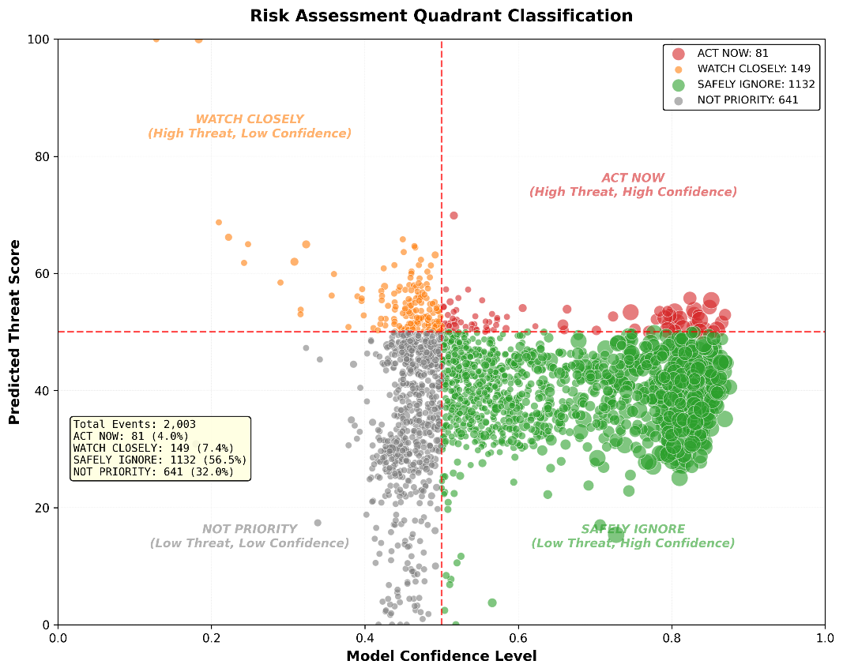
The four-quadrant risk classification framework, which combines threat scores with confidence levels, produced operationally realistic event distributions across the test set of 2,003 unique events. As shown in Figure 7, the majority of events (56.5%, n=1,132) were classified as SAFELY IGNORE (low threat, high confidence), representing routine conjunctions that can be deprioritized without analyst review. The NOT PRIORITY quadrant contained 32.0% of events (n=641), indicating low-risk conjunctions with insufficient observational data for confident assessment. High-threat events were concentrated in the WATCH CLOSELY (7.4%, n=149) and ACT NOW (4.0%, n=81) quadrants, with the distinction based on confidence levels that reflect data quality and prediction certainty.
Figure 7: Risk Assessment Quadrant Classification Dashboard

The ACT NOW quadrant, which includes events requiring immediate operational attention, exhibited collision probabilities ranging from 1.46×10⁻⁸ to 4.41×10⁻⁵, with threat scores exceeding 50 and confidence levels above 0.5. Table 1 presents the top 20 highest-priority events, revealing significant variation in observational patterns. Some events accumulated 23 CDMs over 135 days of tracking, while others triggered high-priority classification with as few as 2 CDMs within a single day. This diversity demonstrates the model's ability to distinguish genuinely urgent situations (high Pc with abundant confirming observations) from preliminary alerts that require additional data. The WATCH CLOSELY quadrant identified potentially dangerous conjunctions where high threat scores were moderated by low confidence, appropriately flagging cases that require refined orbit determination or additional observations before maneuver decisions. Detailed trajectory reports for each of the top 20 events are included in the Appendix.

Table 1: Top 20 High-Priority Events
Event ID | Threat | Confidence | Final Pc | TCA | CDMs | Object 1 | Object 2
49402_13771 | 69.9 | 0.52 | 2.08E-06 | 4/30/2024 14:08 | 5 | KOSEN-1 | SL-3 R/B
32162_43643 | 57.3 | 0.51 | 1.99E-06 | 5/27/2024 14:40 | 2 | FENGYUN 1C DEB | YAOGAN-32 B
25865_43924 | 57.2 | 0.53 | 1.46E-08 | 2/12/2024 0:19 | 2 | SL-16 DEB | IRIDIUM 168
58598_58597 | 55.8 | 0.52 | 2.40E-06 | 1/4/2024 10:55 | 2 | STARLINK-31079 | STARLINK-31087
54073_53841 | 55.8 | 0.82 | 2.04E-07 | 6/10/2024 4:09 | 13 | STARLINK-5146 | STARLINK-4750
53918_51891 | 55.4 | 0.85 | 1.57E-06 | 2/3/2024 5:19 | 21 | STARLINK-5012 | STARLINK-3549
36861_40399 | 55.4 | 0.55 | 3.49E-07 | 4/2/2024 8:07 | 2 | METEOR 2-8 DEB | DMSP 5D-2 F13 DEB
36878_36270 | 55.2 | 0.51 | 7.24E-06 | 4/27/2024 21:13 | 4 | METEOR 2-7 DEB | FENGYUN 1C DEB
17642_41508 | 54.3 | 0.5 | 4.41E-05 | 4/28/2024 22:56 | 4 | COSMOS 1275 DEB | NOAA 16 DEB
42339_39657 | 54.3 | 0.5 | 3.83E-05 | 4/1/2024 9:18 | 3 | NOAA 16 DEB | COSMOS 1867 COOLANT
52000_53544 | 54.2 | 0.85 | 6.79E-06 | 3/6/2024 1:27 | 16 | STARLINK-3653 | STARLINK-4303
45550_48105 | 54.1 | 0.61 | 4.05E-07 | 5/22/2024 6:06 | 5 | STARLINK-1390 | STARLINK-2440
52691_53998 | 53.9 | 0.66 | 4.76E-07 | 2/3/2024 22:42 | 6 | STARLINK-3945 | STARLINK-5128
30197_21420 | 53.8 | 0.52 | 1.00E-10 | 4/13/2024 15:41 | 2 | FENGYUN 1C DEB | SL-8 DEB
50176_53844 | 53.7 | 0.83 | 2.10E-05 | 3/4/2024 11:24 | 35 | STARLINK-3293 | STARLINK-4745
54186_52850 | 53.5 | 0.79 | 3.88E-06 | 1/15/2024 1:15 | 9 | STARLINK-5194 | STARLINK-4187
53912_51883 | 53.5 | 0.78 | 8.68E-06 | 2/16/2024 16:12 | 9 | STARLINK-5059 | STARLINK-3576
46753_45228 | 53.5 | 0.8 | 5.71E-06 | 2/11/2024 20:45 | 23 | STARLINK-1922 | STARLINK-1222
47398_45409 | 53.4 | 0.52 | 4.45E-07 | 2/11/2024 20:31 | 2 | STARLINK-2120 | STARLINK-1282
46129_46791 | 53.4 | 0.75 | 2.72E-06 | 3/4/2024 5:11 | 19 | STARLINK-1623 | STARLINK-1933

Notably, high confidence was distributed across the entire threat spectrum rather than being concentrated in low-risk events, confirming that the model distinguishes between "confident it is safe" and "confident it is dangerous" (confidence calibration detailed in Section 3.4). This classification scheme enables a 96% reduction in urgent alerts requiring immediate analyst attention (from 2,003 events to 81 in the ACT NOW quadrant), demonstrating significant potential for operational efficiency gains in space traffic management workflows.

3.4 Uncertainty Quantification and Confidence Calibration
Monte Carlo Dropout, implemented through 50 stochastic forward passes during inference with dropout layers active (training=True), provided built-in uncertainty quantification without additional architectural complexity or ensemble training. The prediction variance across these passes naturally captures epistemic uncertainty arising from limited or ambiguous observational data. Analysis of the test set revealed a mean uncertainty of 0.127, ranging from 0.037 to 9.81, indicating that the model appropriately expresses varying degrees of confidence across different conjunction scenarios.
The calibration of confidence metrics against observational data quantity validates the MC Dropout approach. As illustrated in Figure 8, confidence levels show a clear positive relationship with CDM count, with events observed through 15-40 CDMs achieving a mean confidence exceeding 0.7, while sparsely observed events 2-5 CDMs typically registered confidence below 0.4. This emergent behavior, resulting solely from prediction variance patterns rather than explicit programming, demonstrates that the model naturally recognizes when it lacks sufficient information for reliable assessment. The overall mean confidence of 0.58 across all test events suggests appropriate epistemic humility, as the model avoids overconfident predictions when faced with limited or noisy data.
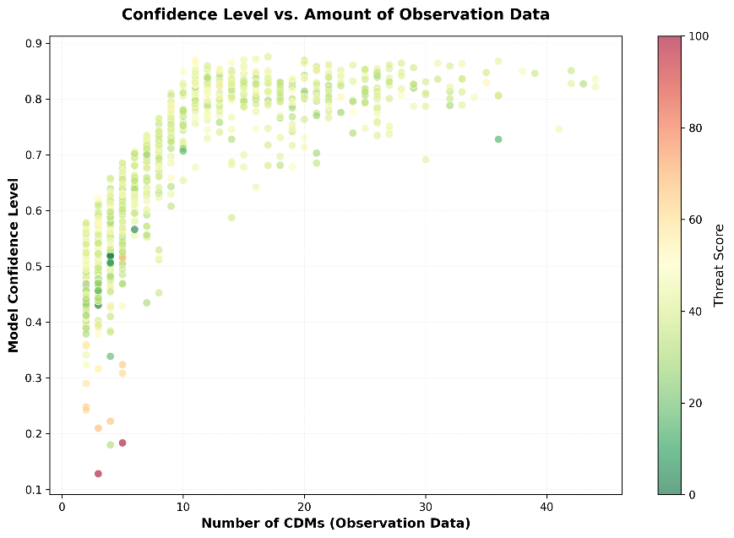
Figure 8: Confidence Level Vs. Amount of Observation Data

Importantly, the distribution of high-confidence predictions spans the full threat spectrum, from confident assessments of safe passages to confident identification of dangerous encounters. Events in the ACT NOW quadrant represent cases where both high risk and high certainty align, providing operators with clear actionable intelligence. In contrast, the WATCH CLOSELY quadrant flags potentially dangerous situations where prediction uncertainty warrants additional observations or refined orbit determination before committing to collision avoidance maneuvers. This confidence-aware classification framework addresses a fundamental limitation of traditional threshold-based screening systems, which provide binary alerts without quantifying the reliability of underlying predictions.

3.5 Model Architecture Selection and Advantages
The bidirectional GRU architecture was selected for its ability to capture the full temporal context in CDM sequences while maintaining computational efficiency. In contrast to unidirectional models, which process sequences in a single temporal direction, the bidirectional configuration processes each sequence in both directions. This approach enables the model to utilize comprehensive contextual information when predicting subsequent CDM parameters. Such a design is particularly valuable for conjunction risk assessment, where both early trajectory indicators and proximity to the time of closest approach influence the evolution of collision probability. Details of the model's structure are shown in Figure 1.
GRU cells were chosen over LSTM units due to their simplified gating mechanism, which reduces parameter count and training time, while preserving comparable sequence modeling capabilities. The resulting architecture, comprising 244,171 trainable parameters, achieves an effective balance: it is sufficiently complex to learn nuanced trajectory patterns across the eight-order-of-magnitude Pc range, yet remains compact enough to be trained in under 25 minutes on standard CPU hardware without the need for specialized computing resources.
The self-supervised learning framework provides significant advantages compared to traditional threshold-based screening systems. Instead of applying fixed Pc thresholds without regard to trajectory context, the model learns from actual CDM evolution patterns, enabling it to identify which trajectory characteristics correspond to credible threats and which indicate false alarms. This data-driven methodology mitigates the labeling bias present in supervised approaches, where human operators must predefine threat categories. The resulting system processes CDMs within milliseconds, facilitating real-time screening of thousands of daily conjunction alerts and allowing human expertise to be concentrated on the small proportion of events (4%) that require immediate attention. This scalability addresses a critical operational challenge as the number of tracked satellites continues to increase.

3.6 Limitations and Future Directions
Several limitations of the current approach should be acknowledged. First, the absence of actual collision outcomes in historical data prevents direct validation of threat predictions against ground truth events, as satellite collisions are extremely rare, occurring approximately once per year worldwide. Consequently, model performance is assessed using surrogate metrics such as collision probability predictions and trajectory evolution patterns, rather than binary collision outcomes. Second, the current implementation treats all space objects equally, without accounting for object-specific characteristics such as maneuverability, operational status, or spacecraft type. Active satellites capable of collision avoidance maneuvers exhibit different risk profiles compared to derelict debris, yet this distinction is not explicitly represented. Third, although the model implicitly captures environmental effects through Conjunction Data Message (CDM) sequence history, it does not directly incorporate external factors such as atmospheric density variations, solar activity cycles, or gravitational perturbations, instead relying on these influences to be reflected in the observed trajectory data.
Future research could address these limitations through several strategies. Incorporating object metadata, such as maneuverability indicators, cross-sectional area, and operational status, as additional input features would facilitate more nuanced risk assessments. Integrating physical environment models, including atmospheric density forecasts, space weather indices, and gravitational harmonics, could enhance prediction accuracy, particularly for extended tracking scenarios. Employing ensemble methods that combine multiple architectures, such as BiGRU, BiLSTM, and Transformers, may improve robustness and provide additional uncertainty quantification through model disagreement metrics. Additionally, active learning frameworks could prioritize low-confidence events that require refined orbit determination or supplementary observations, thereby optimizing the allocation of limited ground-based tracking resources. Despite these limitations, the current system demonstrates operational readiness for conjunction screening, with performance metrics and computational efficiency suitable for integration into space traffic management workflows.

Conclusion
This research addresses the significant challenge of differentiating credible satellite conjunction threats from low-quality alerts amid rapidly increasing space traffic. Analysis of over 185,000 conjunction data messages collected over six months in 2024 demonstrates that self-supervised deep learning effectively learns collision risk patterns from CDM trajectory evolution, without the need for labeled collision outcomes or predefined threat categories.

The bidirectional GRU architecture, trained using self-supervised sequence prediction and Monte Carlo Dropout for uncertainty quantification, achieved a mean absolute error of 0.403 in collision probability prediction and explained 65% of the variance in log-scaled Pc values (R²=0.649). The model effectively assessed risk across an eight-order-of-magnitude range of collision probabilities (10⁻¹⁰ to 10⁻²), with threat scores showing a strong positive correlation with actual Pc values (slope = 2.86). These results validate that meaningful risk patterns can emerge from CDM sequence data by minimizing prediction error, without explicit definitions of dangerous trajectories.

The operational four-quadrant classification framework, which integrates threat scores with MC Dropout-derived confidence levels, yielded realistic event distributions: 56.5% safely ignorable routine conjunctions, 32% low-priority events with insufficient data, 7.4% high-threat cases requiring further observation, and 4% necessitating immediate operational attention. This scheme enables a 96% reduction in urgent alerts requiring immediate analyst review, focusing human expertise on the 81 highest-priority events from a test set of 2,003 conjunctions. Confidence calibration further validated the MC Dropout approach, as prediction uncertainty decreased with increased observational data and high-confidence predictions were distributed across the entire threat spectrum.

This methodology introduces several key innovations to conjunction screening. First, self-supervised learning avoids the labeling bias in supervised classification and overcomes the context insensitivity of fixed-threshold systems. Second, integrated uncertainty quantification via MC Dropout provides confidence estimates without added architectural complexity or the need for ensemble training, addressing a core limitation of traditional binary alert systems. Third, the trajectory-based prediction framework captures temporal evolution patterns that instantaneous threshold screening cannot identify. Fourth, computational efficiency—25-minute training on standard CPU hardware and millisecond-scale inference—ensures accessibility without specialized infrastructure.

The demonstrated performance metrics, together with the transparent and reproducible methodology, position this approach for operational deployment in space traffic management workflows. The custom KVN parser, which addresses data corruption issues, along with the open-source codebase and detailed architectural specifications, enables independent verification and adaptation to various operational contexts. As satellite populations expand and mega-constellations introduce thousands of new objects annually, scalable, automated conjunction-screening systems become increasingly essential. This study demonstrates that data-driven deep learning methods can enhance operational efficiency while maintaining appropriate epistemic humility through uncertainty quantification.

Future research should incorporate object-specific characteristics such as maneuverability and operational status, integrate physical environment models including atmospheric density and space weather, and develop active learning frameworks to optimize ground-based tracking resource allocation. Despite current limitations, this study establishes self-supervised deep learning with uncertainty quantification as a viable and promising approach for assessing the credibility of conjunction alert in the evolving space traffic management landscape.

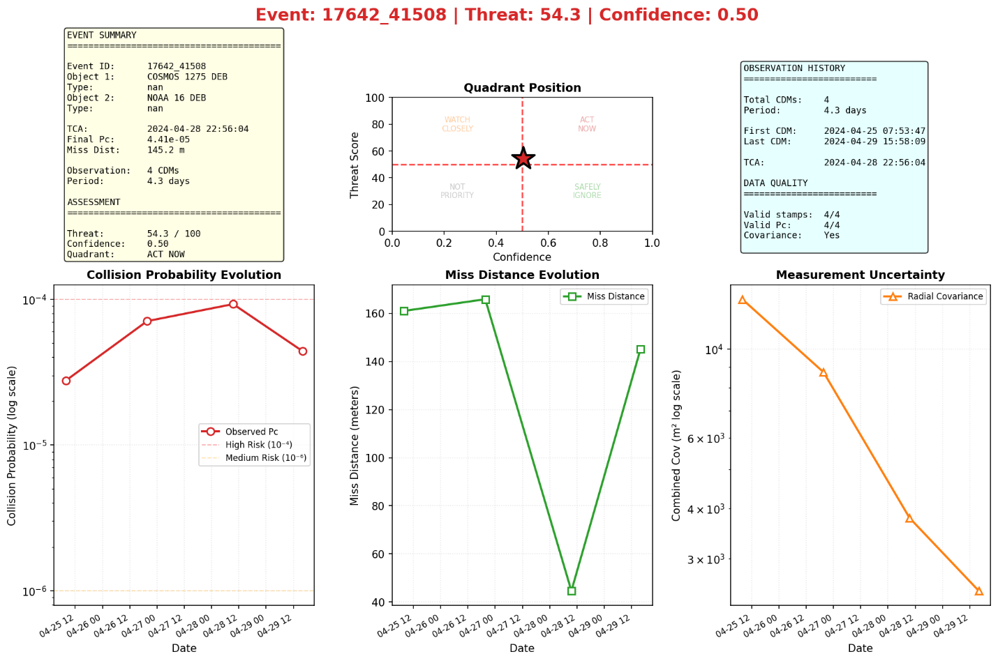
Appendix
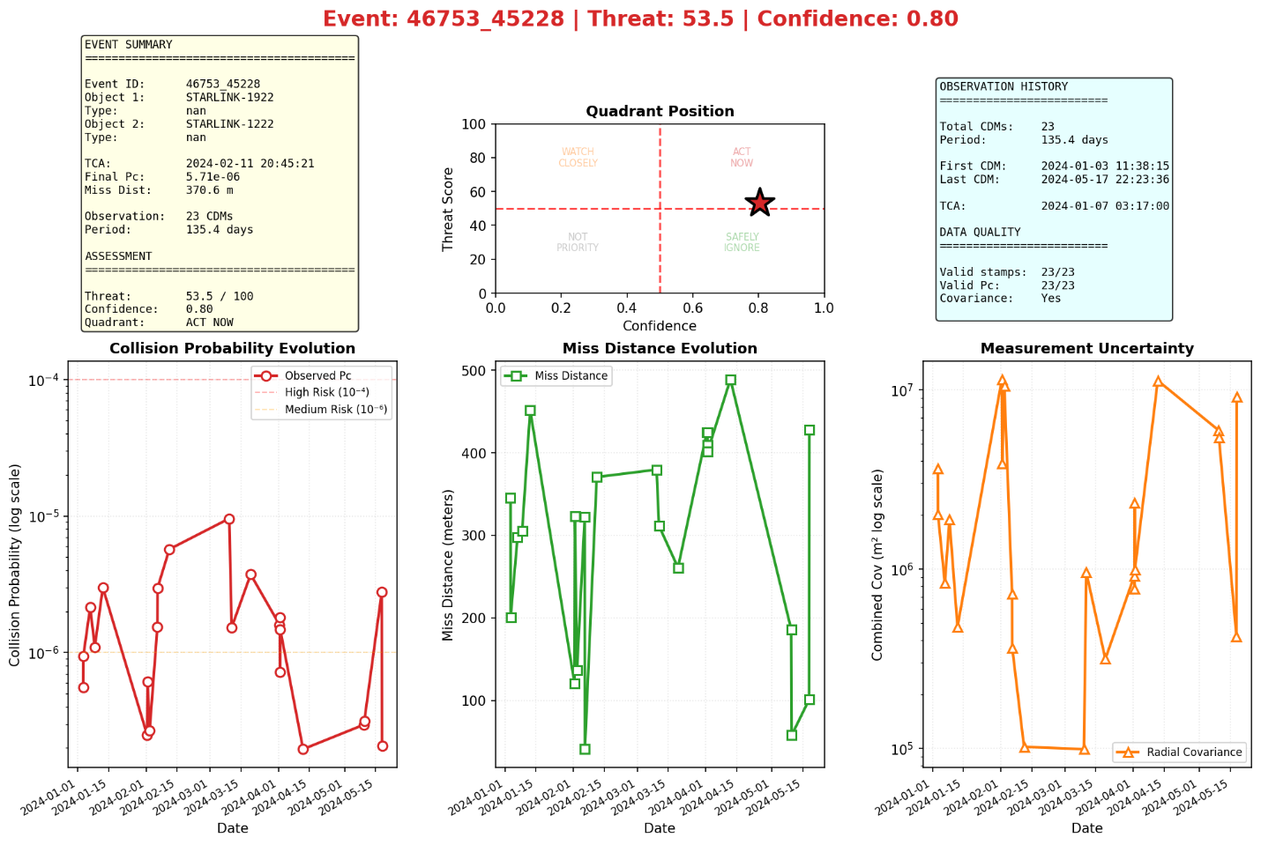

References
[1] “Esa Space Environment Report 2024,” ESA, https://www.esa.int/Space_Safety/Space_Debris/ESA_Space_Environment_Report_2024 (accessed Nov. 10, 2025).
[2] L. Sanchez, M. Vasile, E. Minisci (2020) On the Use of Machine Learning and Evidence Theory to Improve Collision Risk Management. Paper presented at the 2nd IAA International Conference in Space Situational Awareness, Washington, D.C., USA, 14-16 January 2020 (accessed Oct. 25, 2025).
[3] A. K. Mashiku, L. K. Newman, and D. E. Highsmith, "NASA Conjunction Assessment Risk Analysis (CARA) Compendium for Artificial Intelligence and Machine Learning for Satellite Collision Avoidance," in Proc. 26th AMOS Advanced Maui Optical and Space Surveillance Technologies Conference, Wailea, HI, USA, 2025. Accessed: Dec. 12, 2025. [Online]. Available: https://ntrs.nasa.gov/api/citations/20250008251/downloads/AMOS_2025_AIML_Paper_UpdatedContractorAddress.pdf
[4] Y. Qiao, H.-M. Xu, W.-J. Zhou, B. Peng, B. Hu, and X. Guo, "A BiGRU joint optimized attention network for recognition of drilling conditions," Petroleum Sci., vol. 20, no. 6, pp. 3624–3637, 2023. doi: 10.1016/j.petsci.2023.05.021 (accessed Nov. 3, 2025).

[5] D. Xu et al., “A survey on multi-output learning,” arXiv.org, https://arxiv.org/abs/1901.00248 (accessed Dec. 1, 2025).
[6] J. Terven, D.-M. Cordova-Esparza, J.-A. Romero-Gonz&aacute;lez, A. Ram&iacute;rez-Pedraza, and E. A. Ch&aacute;vez-Urbiola, “A comprehensive survey of loss functions and metrics in Deep Learning - Artificial Intelligence Review,” SpringerLink, https://link.springer.com/article/10.1007/s10462-025-11198-7 (accessed Nov. 5, 2025).
[7] Y. Gal and Z. Ghahramani, “Dropout as a Bayesian approximation: Representing model uncertainty in Deep Learning,” arXiv.org, https://arxiv.org/abs/1506.02142 (accessed Nov. 29, 2025).
[8] M. Hasan, A. Khosravi, I. Hossain, A. Rahman, and S. Nahavandi, “Controlled dropout for uncertainty estimation,” arXiv.org, https://arxiv.org/abs/2205.03109 (accessed Nov. 25, 2025).
[9] A. Pim and T. Pryer, “Surrogate modelling of proton dose with Monte Carlo dropout uncertainty quantification,” arXiv.org, https://arxiv.org/abs/2509.18155 (accessed Dec. 2, 2025).
[10] X. Cao, Y. Xu, and X. Yang, “Customer lifetime value prediction with uncertainty estimation using Monte Carlo Dropout,” arXiv.org, https://arxiv.org/abs/2411.15944 (accessed Nov. 28, 2025).

